**Lab 9:** Hadoop, Spark

Code with Output:

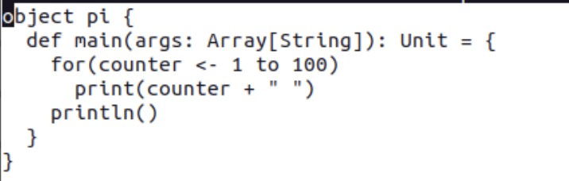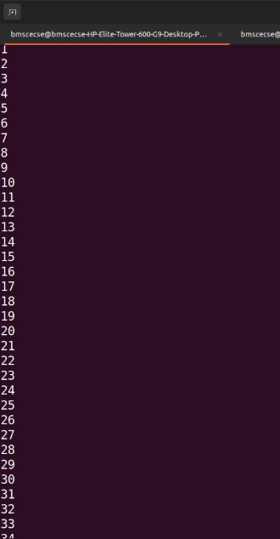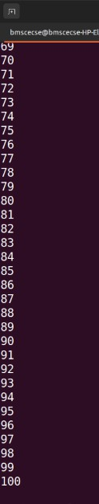Write a Scala program to print numbers from 1 to 100 using for loop

Using RDD and FlatMap

count how many times each word appears in a file and write out a list of words whose count is strictly greater than 4 using Spark

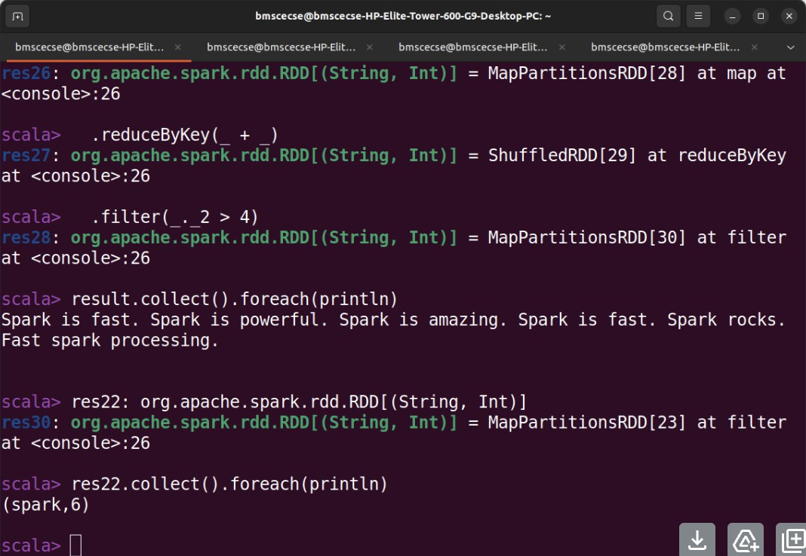

For a given Text file, Create a

Map Reduce program to sort the content in an alphabetic order listing only top 10 maximum occurrences of words.(Hadoop Program)

